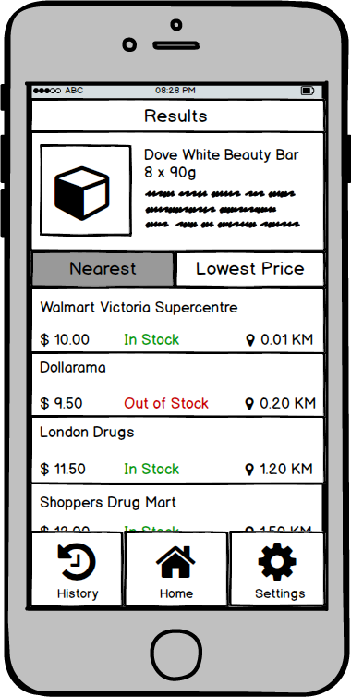

O 828 PM

**Dove White Beauty Bor**

8 x qOg

Nearest Lowest Price

**Walmart Victoria Supercentre**

$ 10.00 In Stock Ο Ο.Ο1 KM

**Dolloroma**

$ 450 Out of Stock Ο Ο.2O KM

**London Drugs**

$ 1150 In Stock 9 120 KM

**Shoppers Drug Mart History Settings**

Ο